***Admin Documentation***

1. **Add Member**:
2. Admin can add member by filling the necessary field.

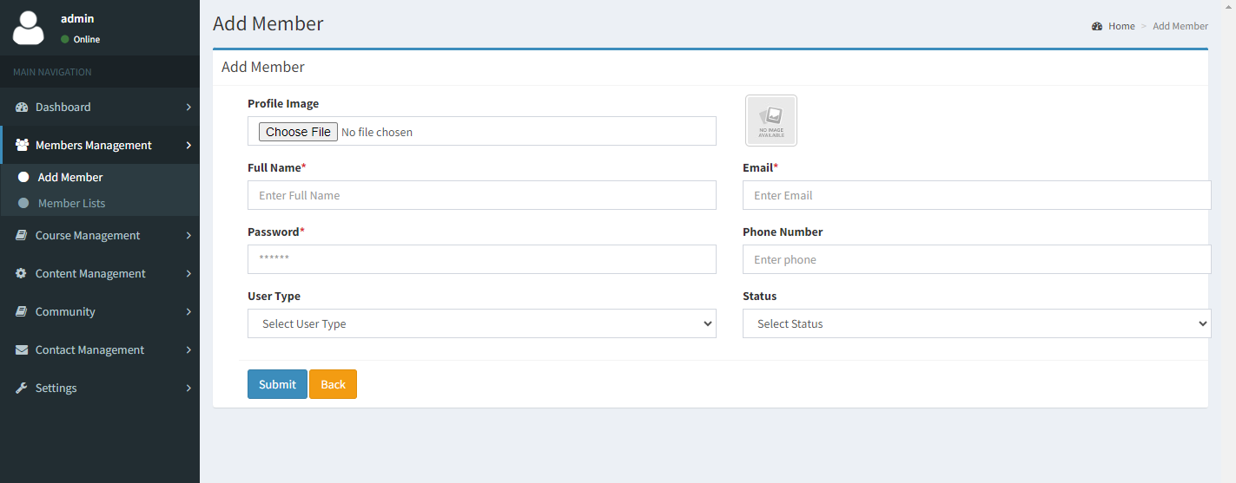

1. **Member List**:
2. All the added member list will be visible here.
3. Admin can Deactivate member by checking the checkbox from the list.

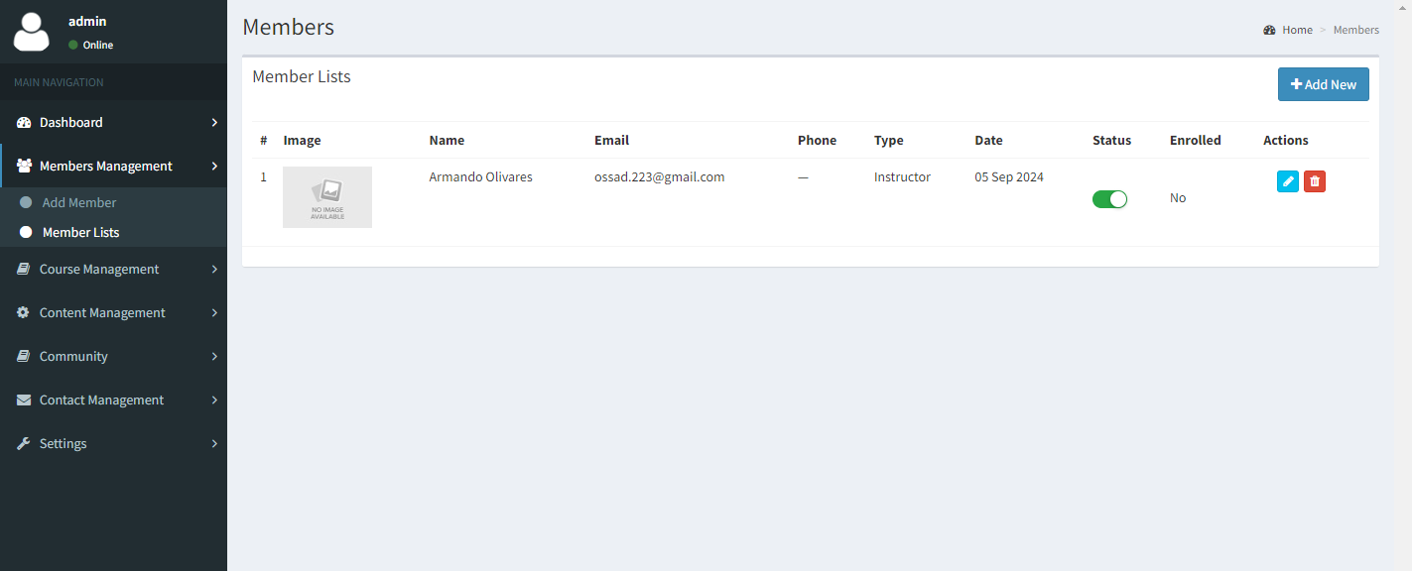

1. **Course Management**:
2. **Add Category**: Admin need to add category, which will be shown as dropdown in add course page.

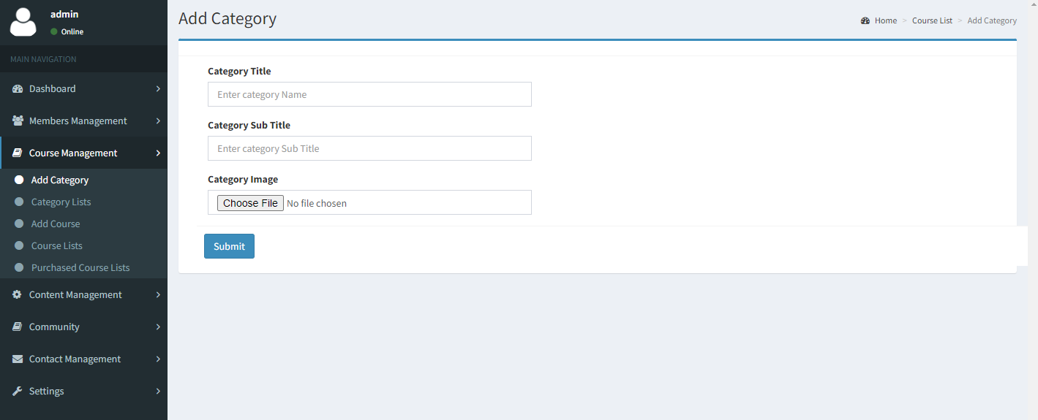

1. **Category List**: All the added category will be listed here. From where admin can edit/delete each category.

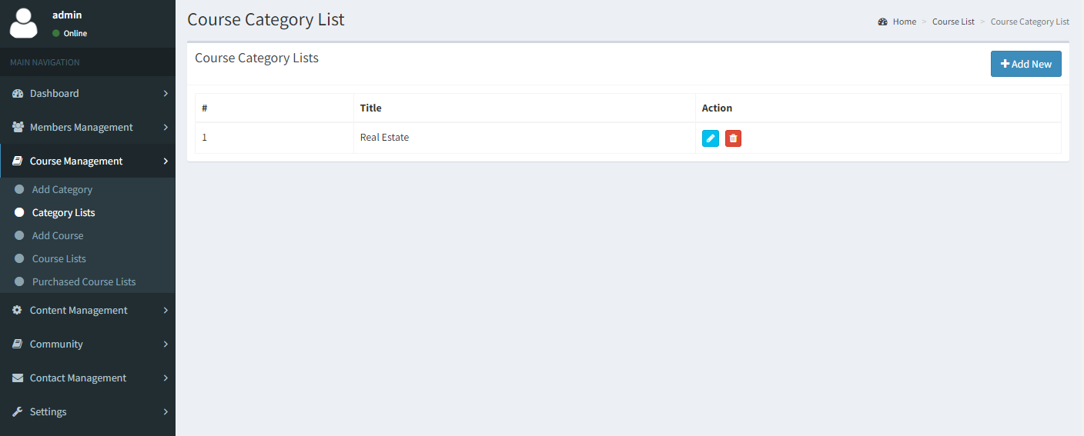

1. **Add Course**: Admin can add course by filling add the necessary fields. While adding the course admin can choose the course price. If the course price is set to **Paid** admin will get to put the price and the **Stripe Price ID.**

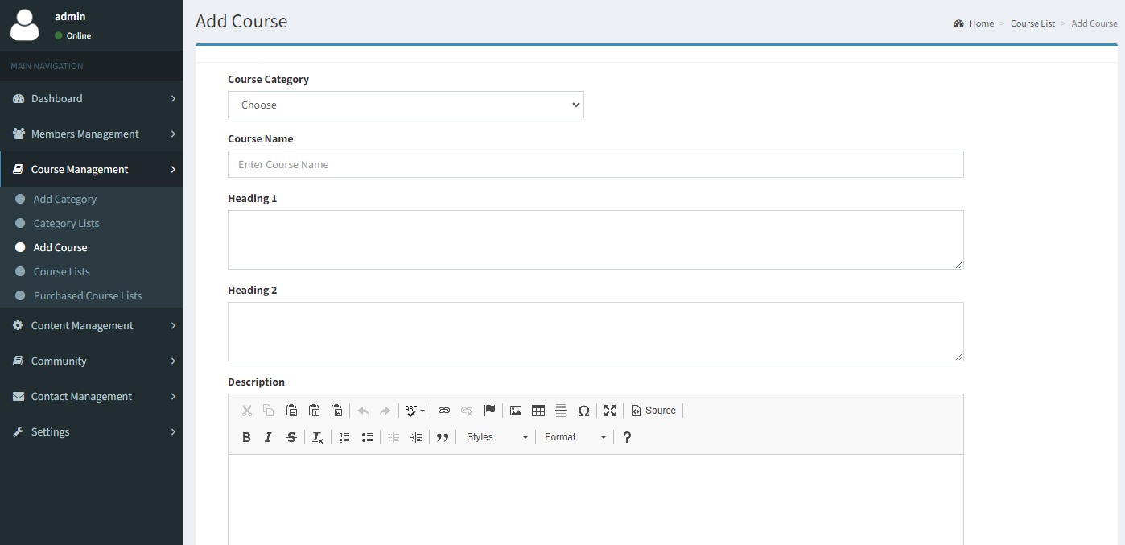

1. **Course List**: All the added course will be shown in the list. From where admin can edit/update and delete course.

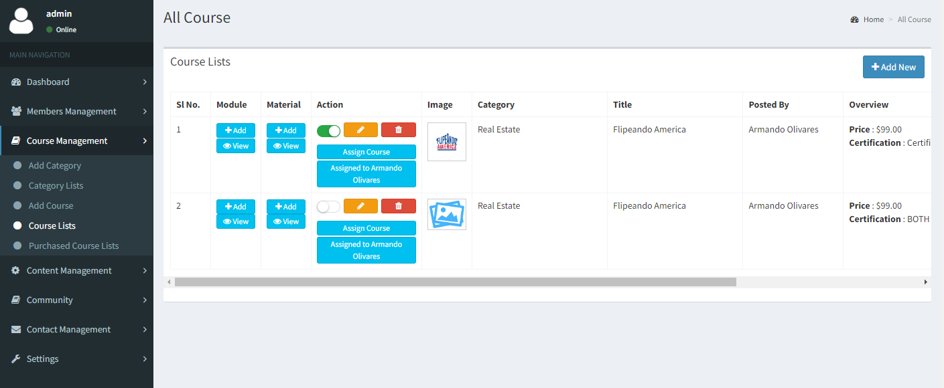

1. **Module (In Course List)**: Admin can add module for every course by clicking on the “+ Add” button for every course.

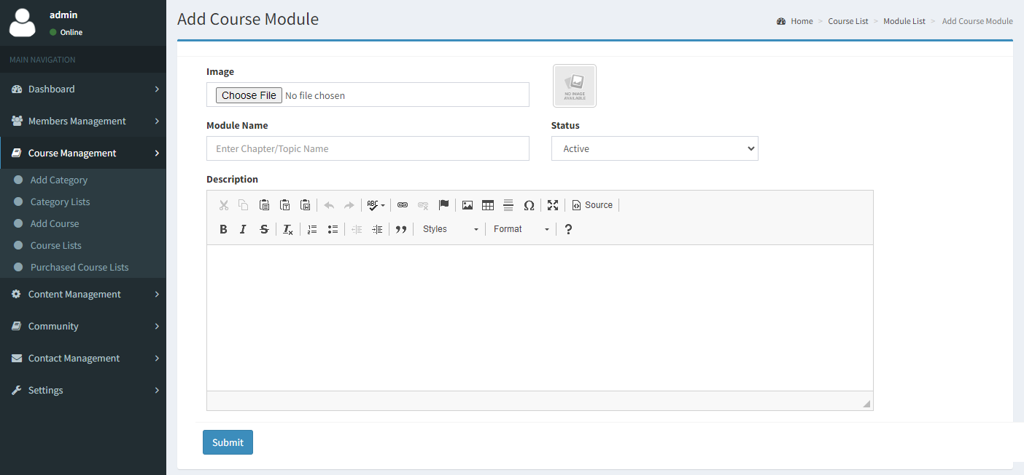

1. Module List: After adding module for a particular course, it will appear in the Module list. Also admin can view module for each and every course by clicking on “View” button from the course list.

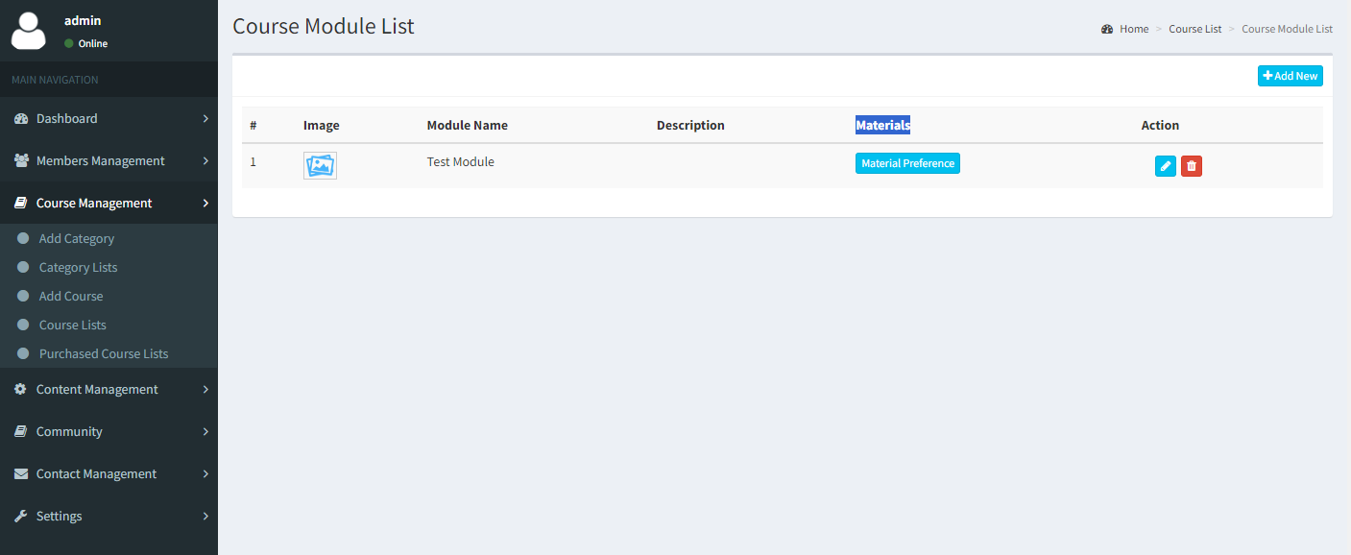

1. **Material**: Admin can add material for a particular module by clicking on the “Material Preference” from course module list or from the course list page. If admin want to add material from the course list page, it will be redirect the to the add material page, from where admin need to choose “**Module Name**” & “**Material Type**”. Please see below screenshot for options.

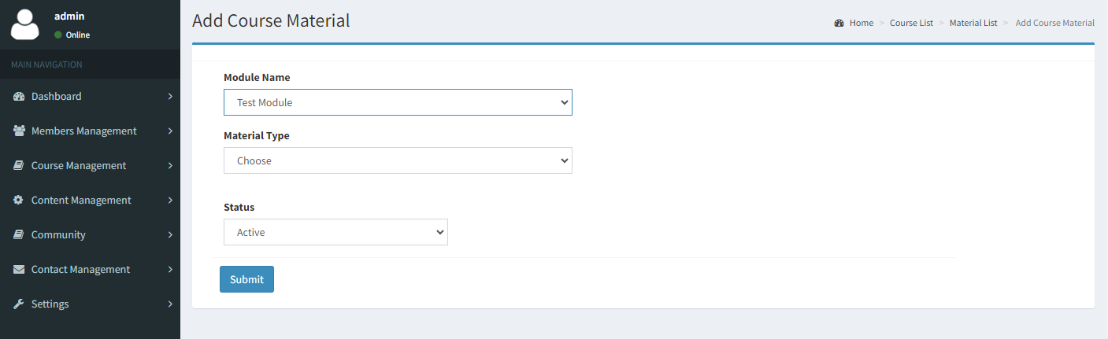

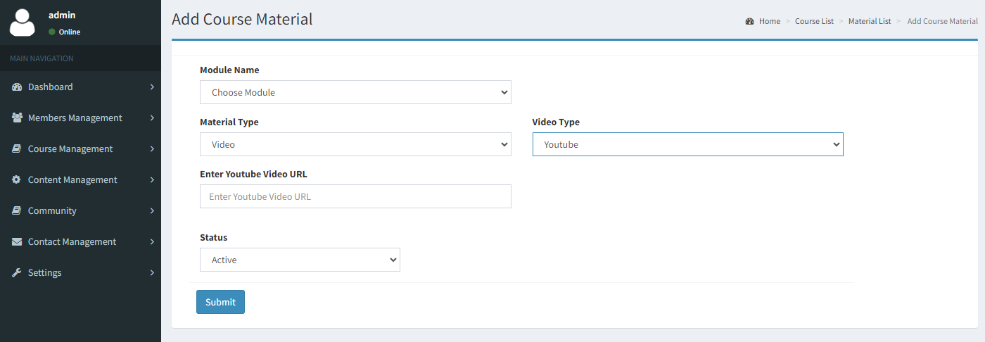

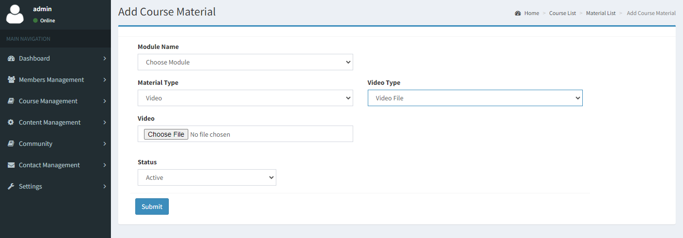

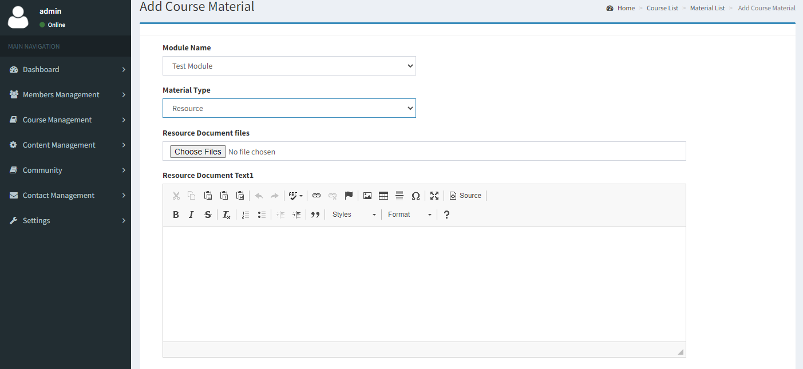

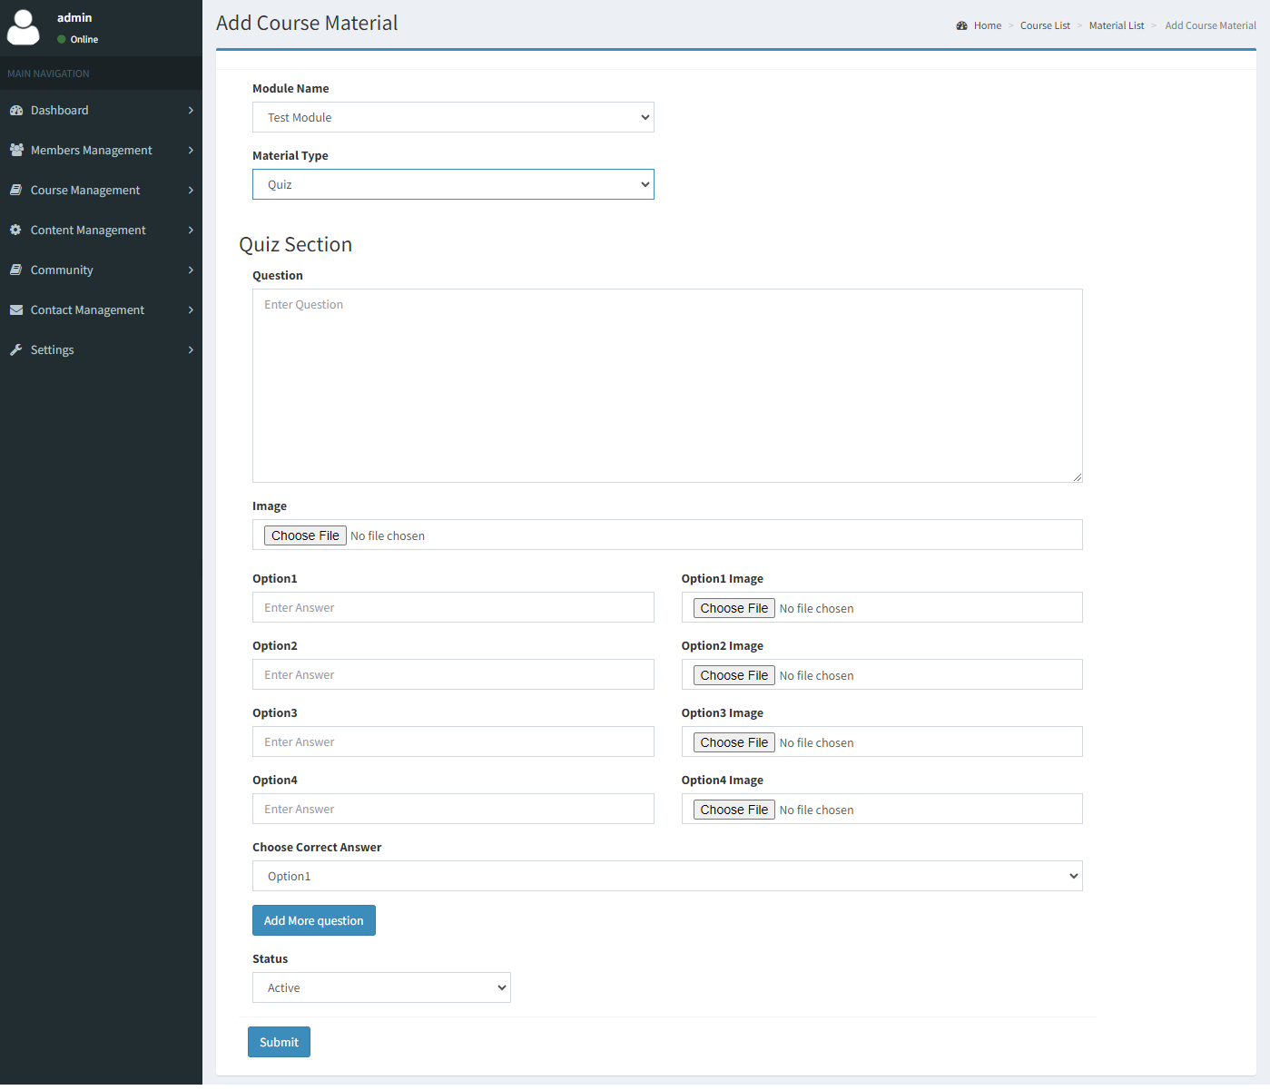

***Note: Admin can add multiple quiz by clicking on the “Add More Question” button for each and every module.***

1. **Assign Course**: Admin can assign student to a particular course by clicking on the “**Assign Course**” button. A popup will open while clicking on the “Assign Course” button, where admin can see the list of student name listed there. Assign the course by selecting single/multiple student at a time. For multi select press (**CTRL for windows user**, **Command for apple user**) from keyboard.
2. **Assign Instructor**: Admin can assign instructor for any course, by clicking on the “**Assign Instructor**” button. This feature is only available if the course is added from the admin portal.

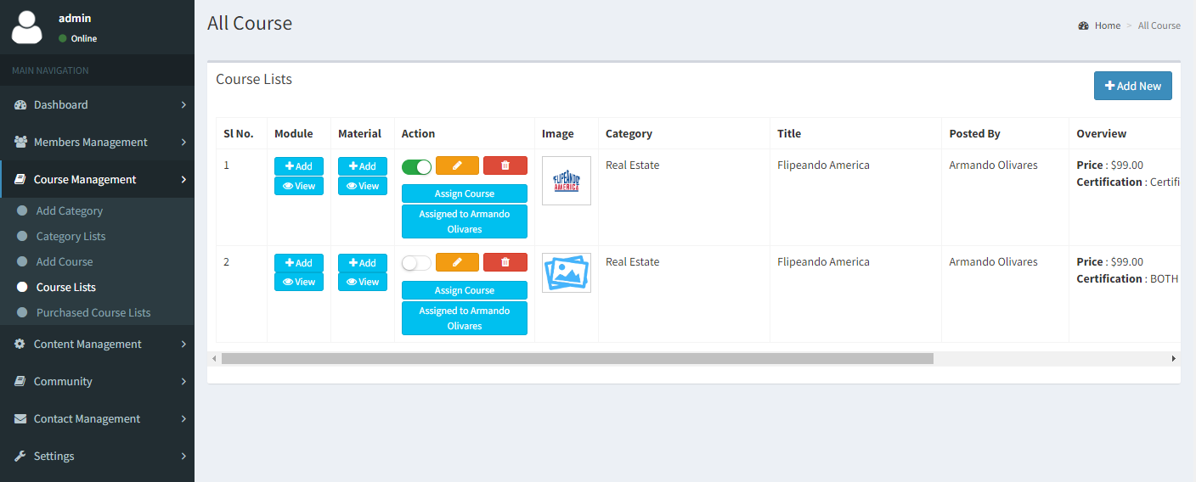

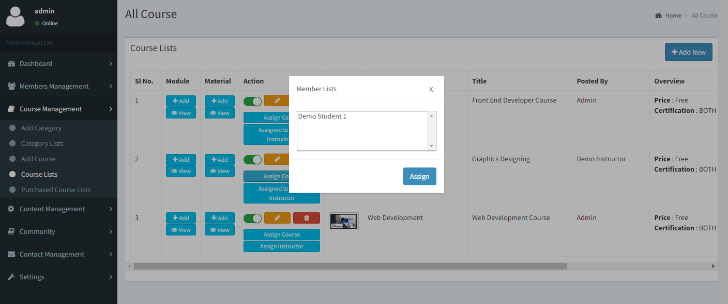

1. **Purchased Course**: All the purchase coursed will be listed here.

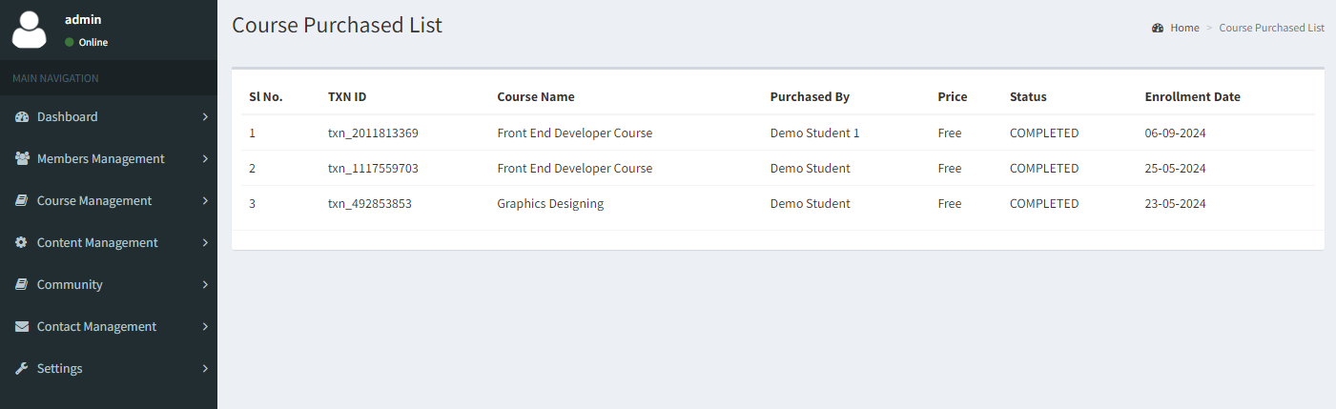

1. **Content Management**:
2. Admin can edit content by clicking on the pencil icon.

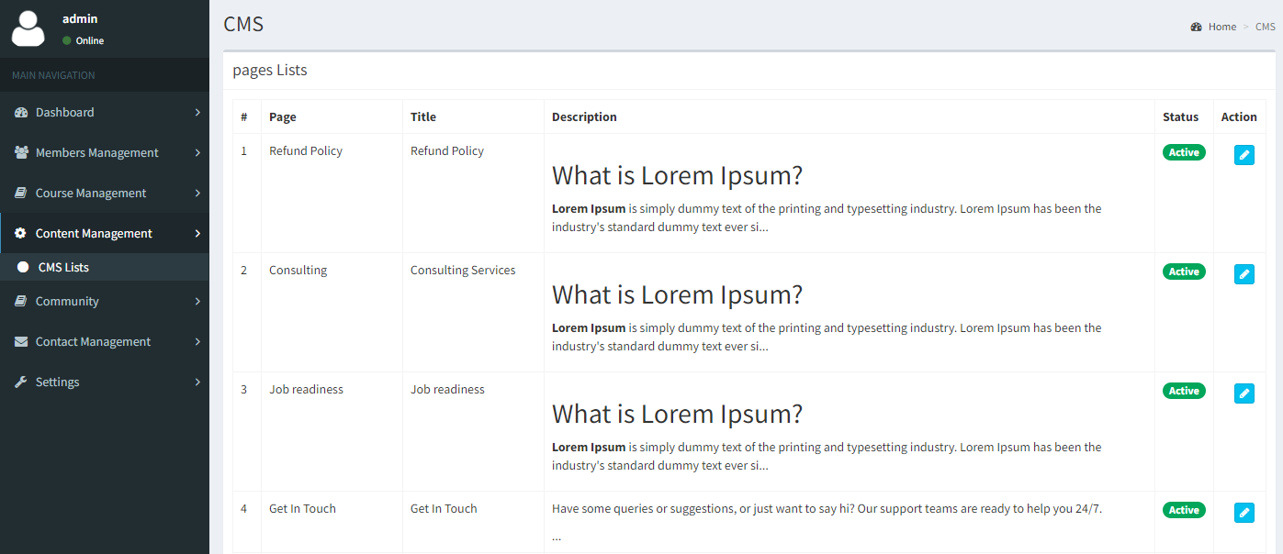

1. Update content and click on save button to reflect it in frontend.

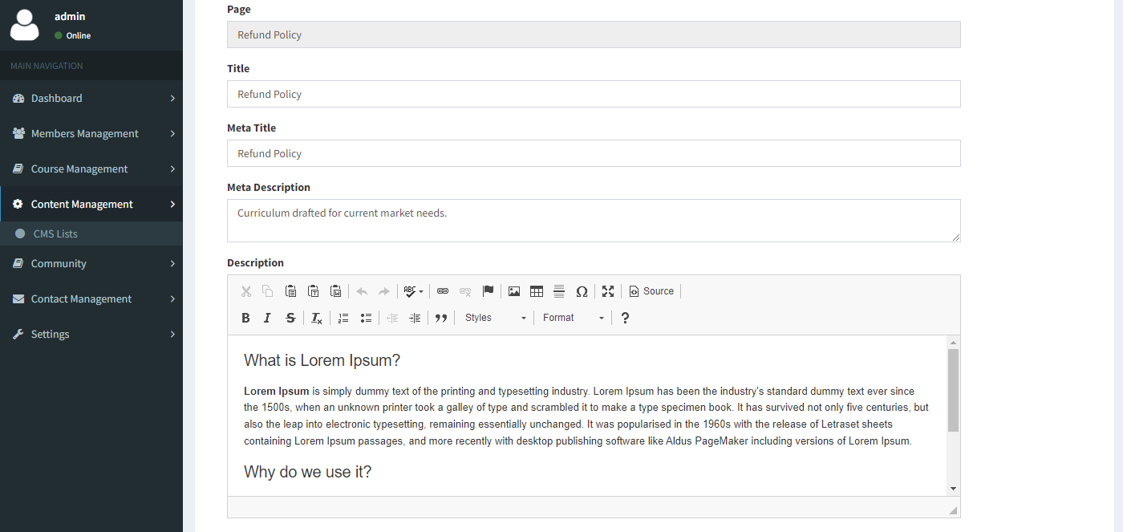

1. **Community**:
2. **Add Community**: Admin can add community separately or course specific.

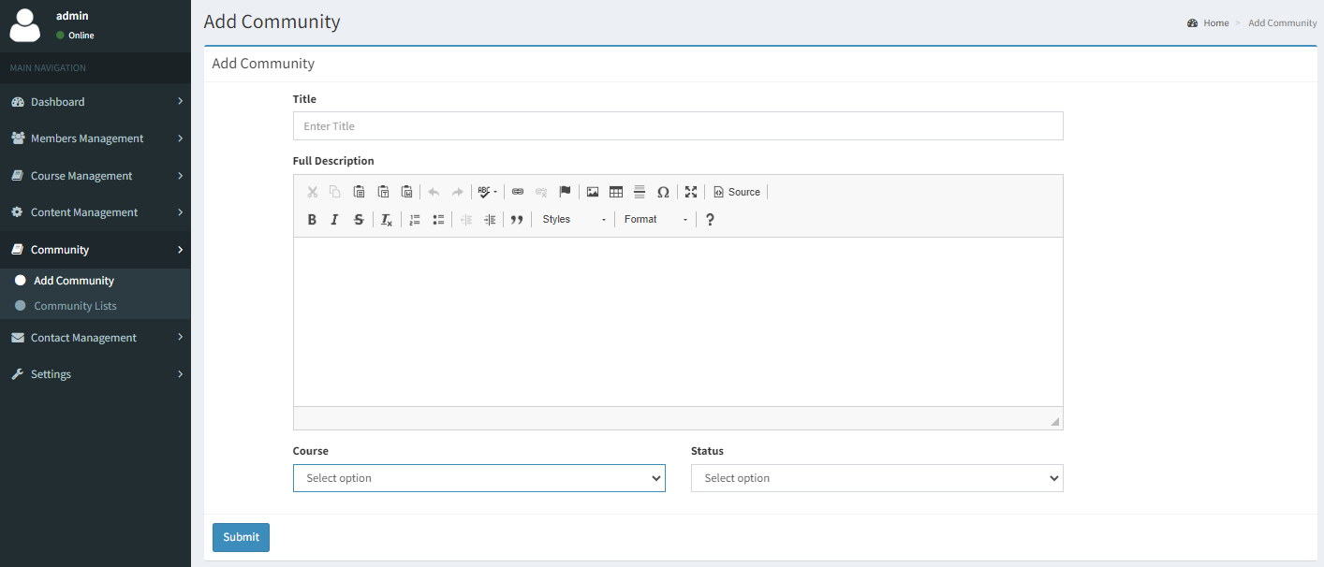

1. **Community List**: Added community will be listed here.

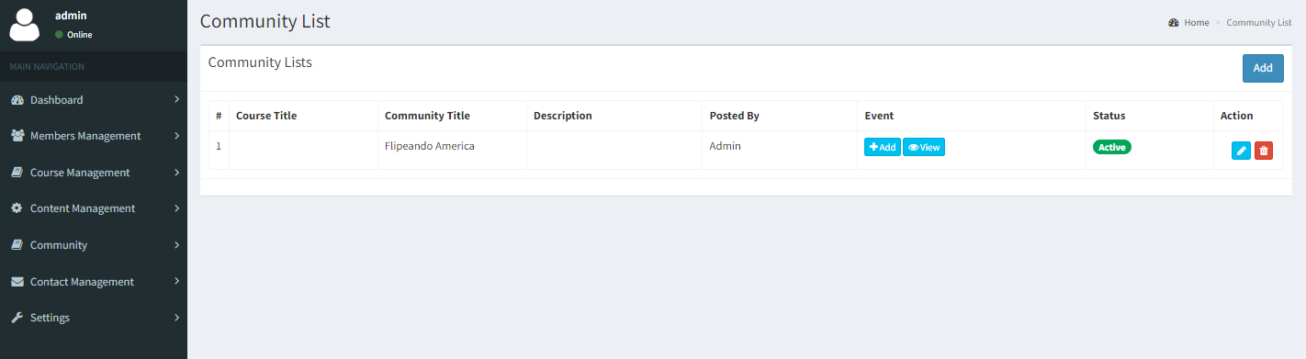

1. **Community Event Add**: Admin can add community event based on each community.

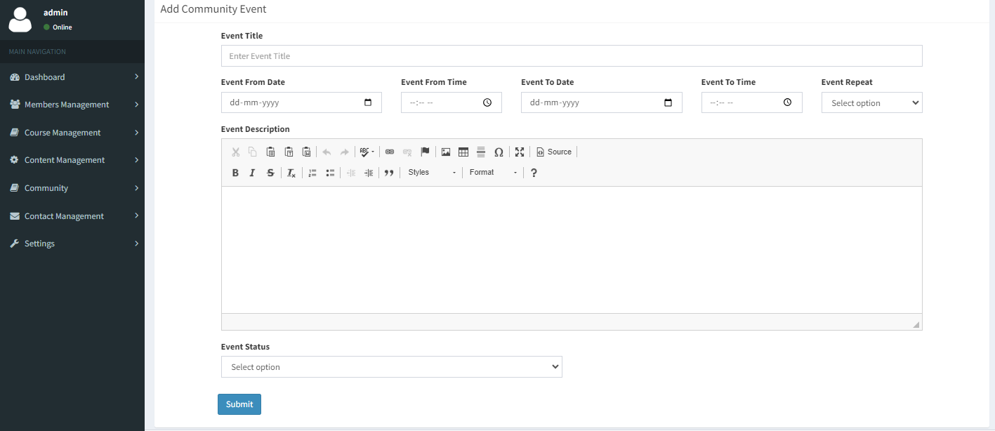

1. **Community Event View:** Admin can view existing community event in.

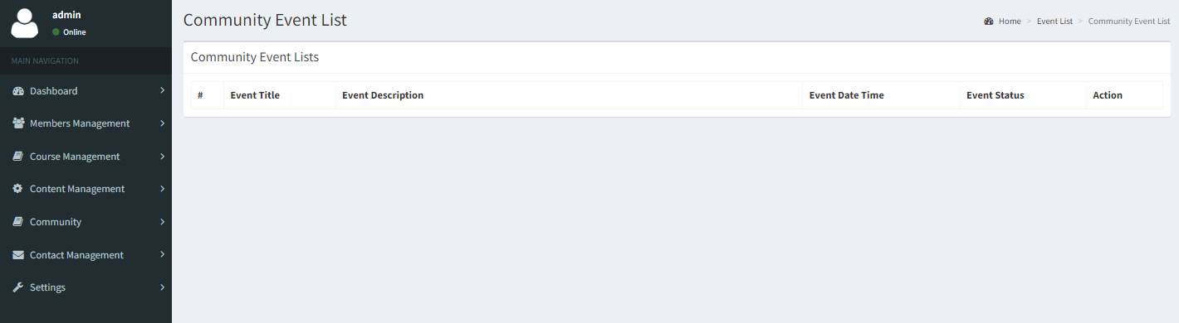

1. Contact Management:
2. Contact Form: All the query posted from contact from will be listed here.

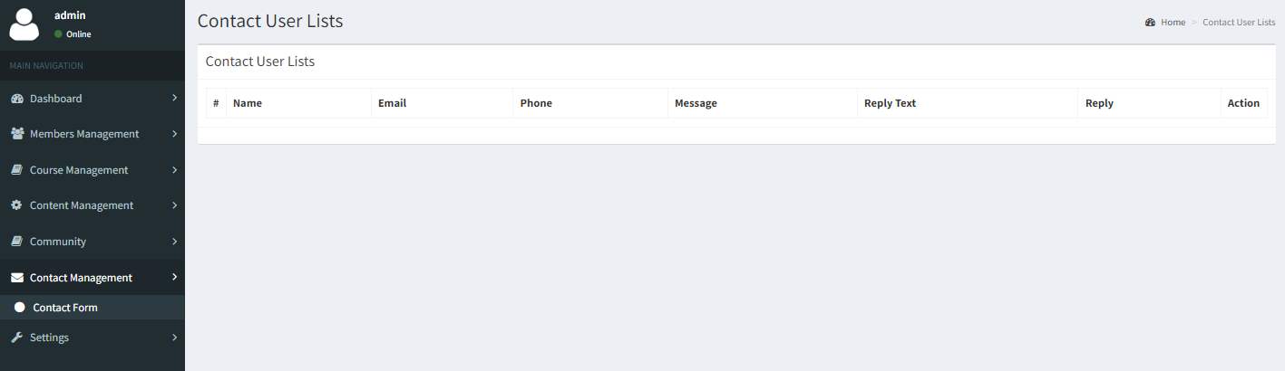

1. Settings: To manage Website information.

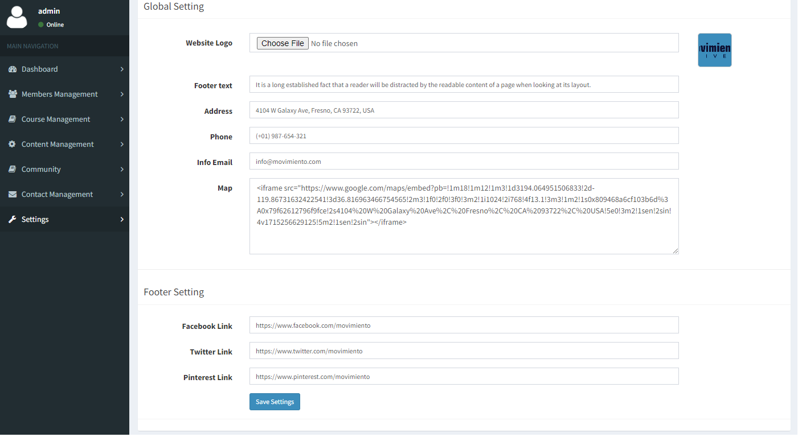

***NOTE: All the data showing in the screenshot are taken from development server.***